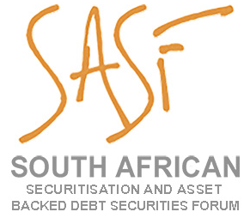
MEMBERSHIP APPLICATION FORM

- ORGANISATION DETAILS

Firm / Company Name
Vat Registration Number

- ORGANISATION’S ADDRESS
Street Address
City |  |  |  |  | Province |  |  |  | Postcode
Country (If outside South Africa)
Telephone No
Postal Address |  |  |  |  |  |  |  |  | Postcode
Country (If outside South Africa)
Website

- PROPOSED NOMINATED REPRESENTATIVE

Name
Title in Organisation
Street Address
City |  | Province |  |  |  | Postcode
Postal Address
Direct Telephone
Cellphone | _______________ | Email | _____________________________________

All enquires & applications should be directed to:
South African Securitisation and Asset Backed Debt Securities Forum
PO Box 366 Plumstead 7801
Telephone 083 457 5260
Securitisationforum.sa@outlook.com

- ANNUAL FEE & PAYMENTS DETAILS
Membership fees are determined on a pro-rata basis for the membership year beginning 1 March to 28 February. The size of the organisation determines the full 12-month membership. Payment of fees is required within 14 days of the receipt of the membership invoice.

- DECLARATION
The Applicant applies for membership in the South African Securitisation and Asset Backed Debt
Securities Forum for the 2024/2025 subscription year and agrees upon approval of its application:

to be bound by the Rules from time to time of the South African Securitisation and Asset Backed
Securities Forum (the Rules’).
to ensure compliance with the Rules by the Applicant’s proposed Nominated Representative.

SIGNED for and on behalf of
(INSERT FIRM / COMPANY NAME OF APPLICANT)
by
(FIRST PROPOSED NOMINATED REPRESENTATIVE)
Date

- YOUR BUSINESS

Please tick the appropriate category that best describes your organisation (tick the box)
 | ☐ | Issuer | ☐ | Investor
 | ☐ | Investment Bank | ☐ | Law Firm
 | ☐ | Trustee | ☐ | Accounting Firm
 | ☐ | Rating Agency | ☐ | Other (please specify)

Please summarise the nature of your business

All enquires & applications should be directed to:
South African Securitisation and Asset Backed Debt Securities Forum
PO Box 366 Plumstead 7801
Telephone 083 457 5260

